Introduction
Your Project Title
Students | Ronnie Rozo, David Shabo | Fall
Students | Ronnie Rozo, David Shabo | 2013
Advisors | Dr. Bassem Alhalabi | 2013

For this project our initial plan was to make a mini security system, it involved a toy pellet shooter that would point to where an object would be passing a sensor and the shooter would then fire a pellet. This plan then changed to using a laser pointer set atop a servo motor in conjunction with two distance sensors.

Description
The values from sensor 1 and sensor 2 were then used with the Pythagorean Theorem to determine the location the servo motor would need to turn. In the picture these distance sensors correlate to the x and y axis, and the servo motor. The servo motor would then turn to an angle depending on the distances used to determine the distance between it and the laser set atop of the servo motor. The servo would then calculate using the formula to find the angle. When the servo has completed that, it would then convert the angle to microseconds. This would make a delay on the servo, which would create a pulse, which that will allow the servo motor to turn to the correct angle. When the servo has the value for the microsecond, it will then turn to that angle.

Future Enhancements

Some future enhancements we had in mind was the idea for the laser to also turn vertically, with our current project we focused on a plain 2-d

form where the laser would turn left and right. With added distance sensors and an extra motor a 3-d aspect to this project could be possible, the extra motor would turn up and down and the sensors would form the z axis in correlation to this project.

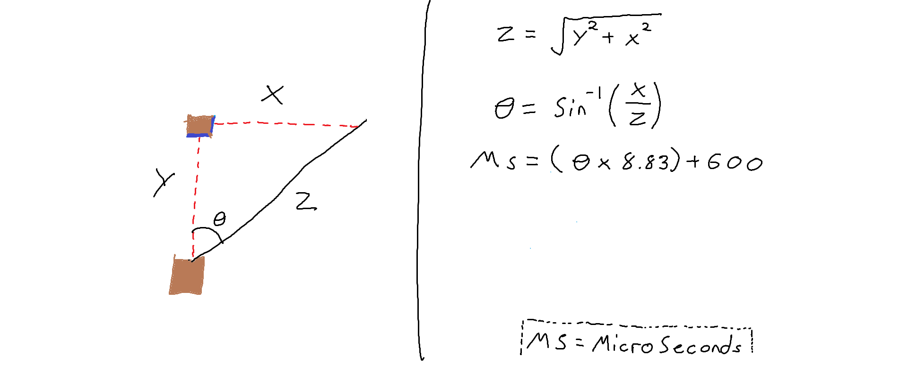
Conclusion

We had a lot of fun learning to use these sensors in conjunction with our project, we were unfamiliar with using the microcontroller as well as Code Composer to program it. But the teaching aids and the professor were more than capable in helping us along the way. The only regrets from this project, were that we weren't able to turn off the pull up resistors and had very little experience using relays.

